CU Denver | Anschutz Medical Campus: CU Careers Candidate Care Guide

Overview

The University of Colorado Denver | Anschutz Medical Campus is committed to providing an exceptional applicant experience created through inclusive, timely, and transparent communication. As a recruiter or HR Business Partner, you represent the University and play a key role in fostering a positive applicant experience. Applicant experience is crucial in the hiring process. As applicants can have multiple opportunities to consider, providing a positive applicant experience provides us with a competitive advantage to aid in the recruitment of current and future career opportunities.

This guide will provide a clear overview of the dispositioning and notification process in CU Careers. Following this guidance will help us create positive, lasting connections with applicants and fulfill our compliance obligations.

Investing in Internal Talent:
As part of our commitment to candidate care, the University of Colorado is dedicated to investing in and developing our internal community (including CU Boulder, Colorado Springs, Denver, and Anschutz Medical Campus). Some ways that we can foster internal talent include:

- Developing preferred qualifications that speak to a candidate’s experience working within the University of Colorado system (all locations)
- Identify internal candidates through CU Careers by adding pre-screening questions, reviewing email addresses provided as part of the application and/or experience outlined in a resume or cover letter
- Use custom notifications in Taleo, email or phone when communicating with internal candidates
- *Use candidate care to develop employees and continue to encourage their career progression at CU

*When possible, we highly recommend providing personal notifications that include professional development, feedback, encouragement, and support when working with candidates who are a member of your team/department/school/college.

The Talent Acquisition Team is here to help if you would like any support navigating candidate care for internal employees.

Accessing a Requisition in CU Careers

- From the CU Careers Home Page, click the Requisitions option under the Quick Access section.

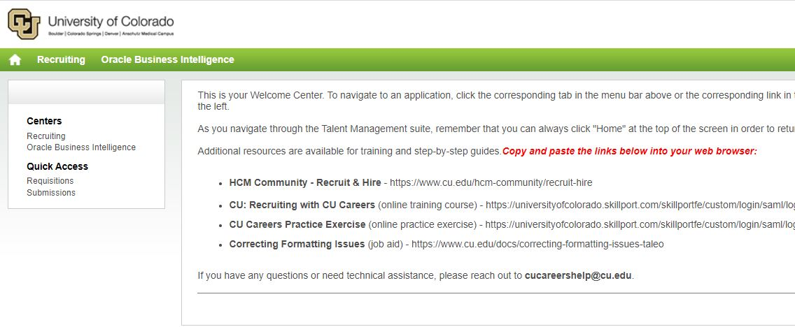

- This will take you to a list of Requisitions that you own and/or collaborate on. You can narrow your search results by using the filter options on the left-hand side of the screen.

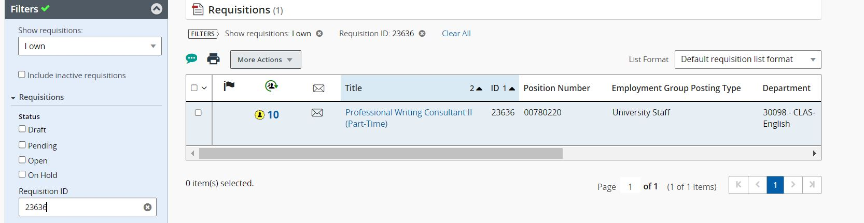

- Once you find the corresponding Requisition, click into the blue position title. This will take you the recruitment home page and allow you to disposition and notify candidates tied to this specific search.

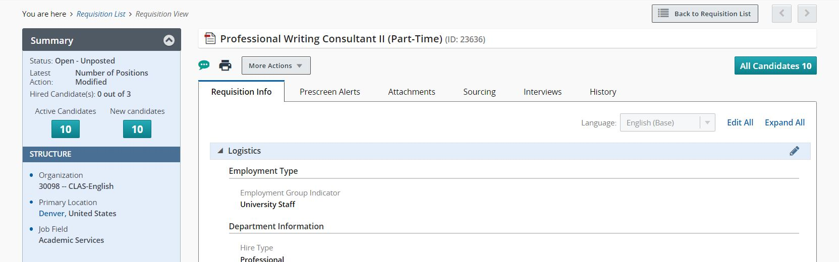

- Throughout the search process, you can use the filter options on the left-hand side of your screen to select, disposition and notify candidates. Note: Candidates are batched by their step/status. If you plan to disposition and notify more than one candidate you must select individuals in the same step/status or batch.

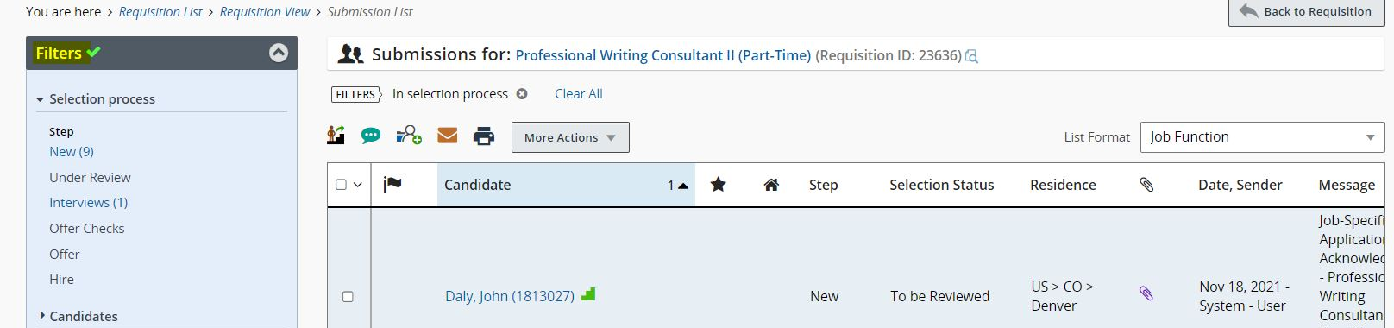

Dispositioning & Notifying Candidates (Candidate Care)

- In alignment with the University’s commitment to candidate care, we ask that Departments disposition and notify candidates at the conclusion of each major stage of the recruitment process.

Major Stage of the Recruitment Process | Groups to Disposition
Applicant Screening | Meets Min Quals, Does not Meet Min Quals, Not Selected, & Selected for Interviews
1st Round Interviews | 2nd Interview, Applicant Withdrew, & Not Selected (including candidates waitlisted for interviews)
2nd Round Interviews | Recommended for Hire, Applicant Withdrew, Not Selected (including candidates waitlisted for 2nd interviews)
New Hire Identified | Disposition all remaining active candidates (*including candidates who applied late in the application process)

- After applicant screening is complete, the Department will disposition and notify all candidates who applied within the full-consideration window.

- Dispositioning & Notifications: Candidates who did not meet all of the minimum qualifications of the role.

  - Click into the “All Candidates” button.

- Select all candidates who did not meet MQs by checking the box next to their name. Then click the More Actions drop down menu.

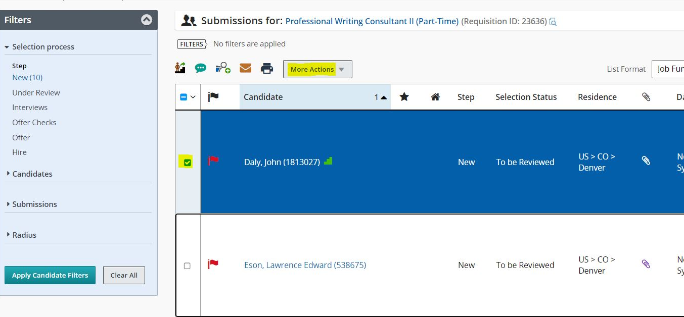

- Within the drop-down menu select the “Change Step/Status” option.

- Change the Status to “Not Selected”, select the most appropriate Details of Disposition, and check the send correspondence box. Click on the Apply and Proceed to Next Action button.

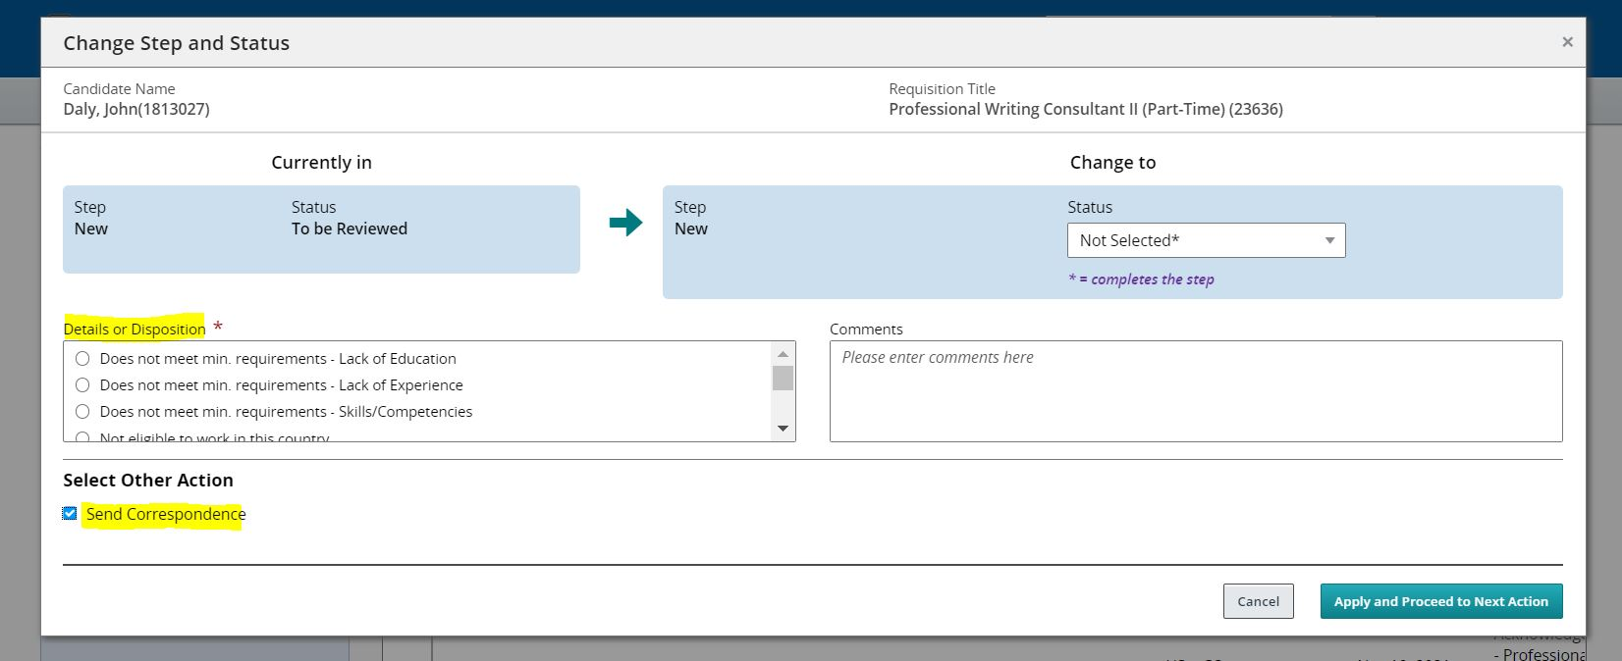

- The following window will populate. No changes need to be made to this section. Just click Next.

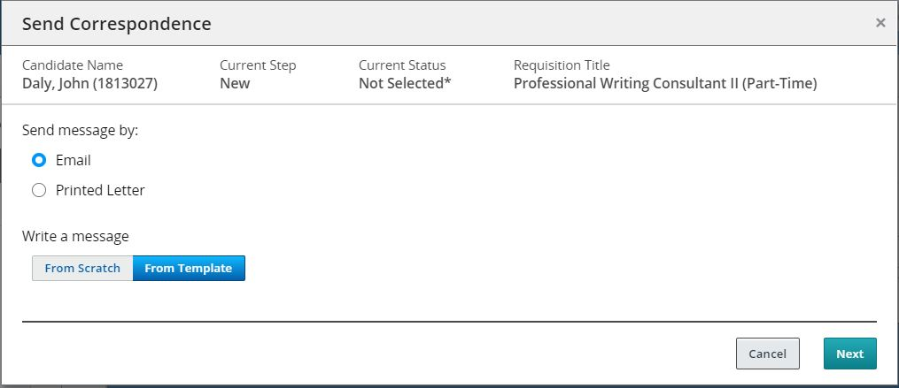

- Scroll through the options on the left-hand side of the screen and select the following template: “UCD Not Selected: General Notification”. Click the Select Template button. NOTE: Please contact your TAC if you need assistance with candidate inquiries.

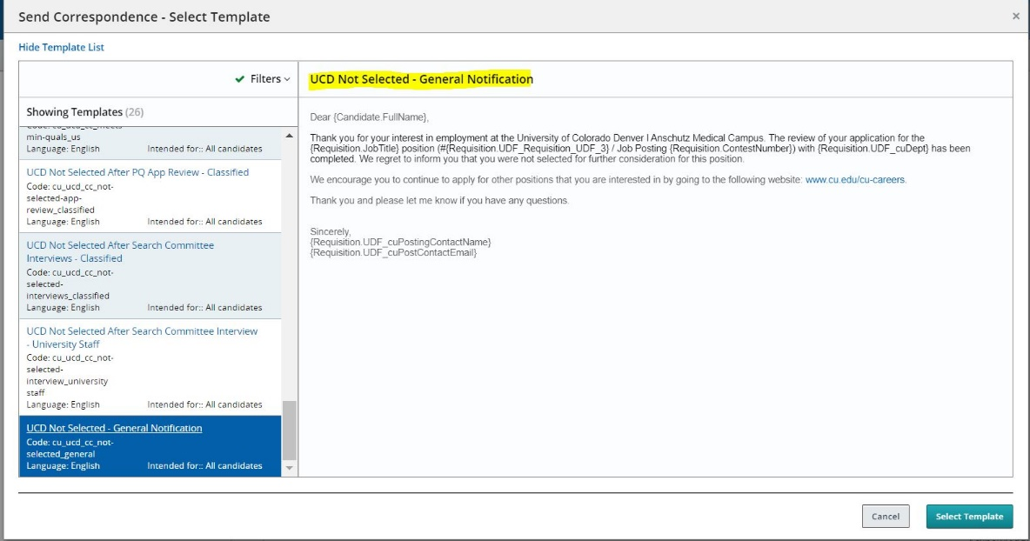
- The system will populate a preview of the notification for your review. If all elements look accurate, click the Send & Close button.

Best Practice Tip: Please do not edit the subject line or email message, as the formulas listed will automatically pull information from CU Careers and customize your message for each candidate. Ex. Dear {Candidate.FirstName} will translate to Dear John, when you send the message.

- Dispositioning & Notifications: Candidates who met all MQs. NOTE: Candidates at this point in the recruitment process may be routed into three categories.

Candidates who meet all MQs, but have not been identified for interviews.

  - Select all applicable candidates by checking the box next to their name. Then click the More Actions drop down menu.

  - Within the drop-down menu select the “Change Step/Status” option.

  - Confirm that “Meets Minimum Qualifications” is in the status bar. Then click Apply and Continue.

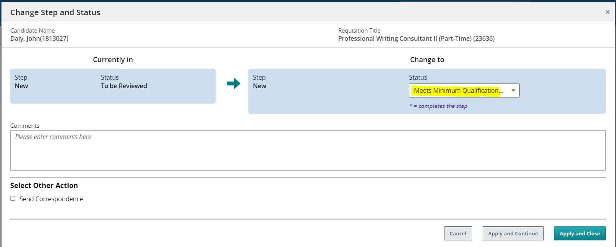

  - Change the Status to “Not Selected”, select the most appropriate Details of Disposition, and check the send correspondence box. Click on the Apply and Proceed to Next Action button.

  - The following window will populate. No changes need to be made to this section. Just click Next.

  - Scroll through the options on the left-hand side of the screen and select the following template: “UCD Not Selected: General Notification”. Click the Select Template button. NOTE: Please contact your TAC if you need assistance with candidate inquiries.

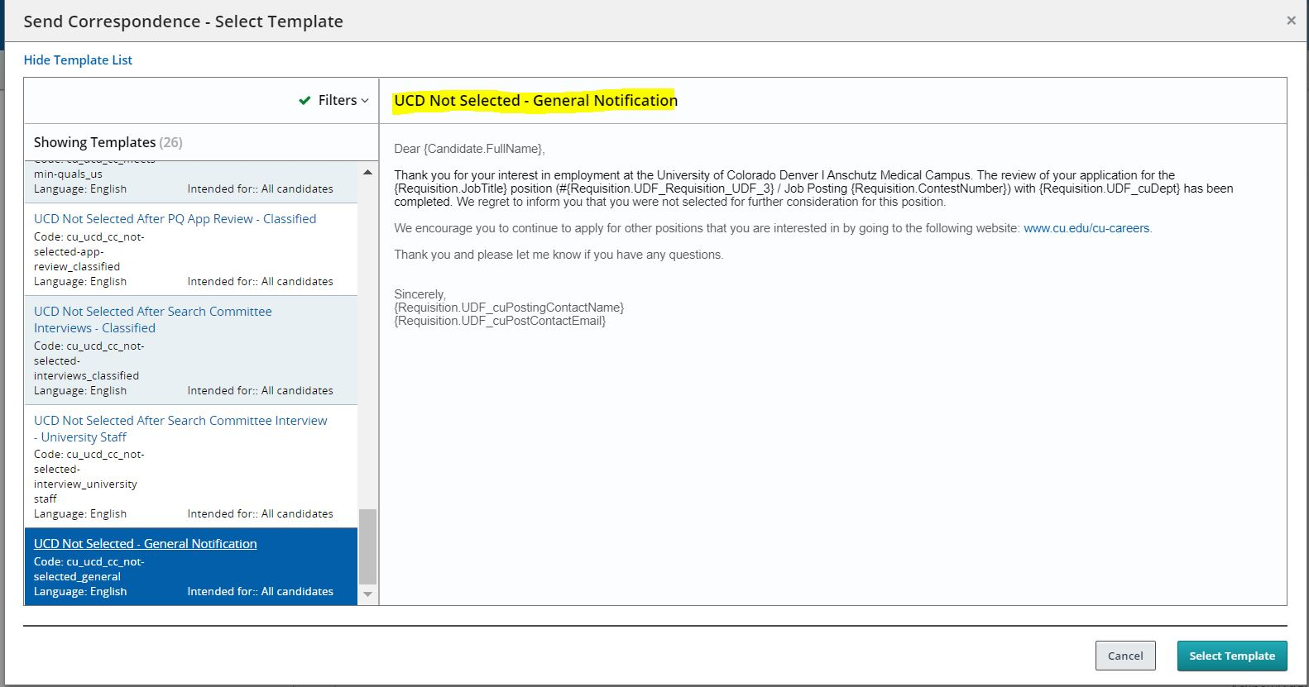

  - The system will populate an example of the notification for your review. If all elements look accurate, click the Send & Close button.

- Dispositioning & Notifications: Candidates who met all MQs. NOTE: Candidates at this point in the recruitment process may be routed into three categories.

Candidates who meet all MQs and have been waitlisted for interviews.

  - Select all applicable candidates by checking the box next to their name. Then click the More Actions drop down menu.

  - Within the drop-down menu select the “Change Step/Status” option.

  - Confirm that “Meets Minimum Qualifications” is in the status bar and check the send correspondence box. Click on the Apply and Proceed to Next Action button.

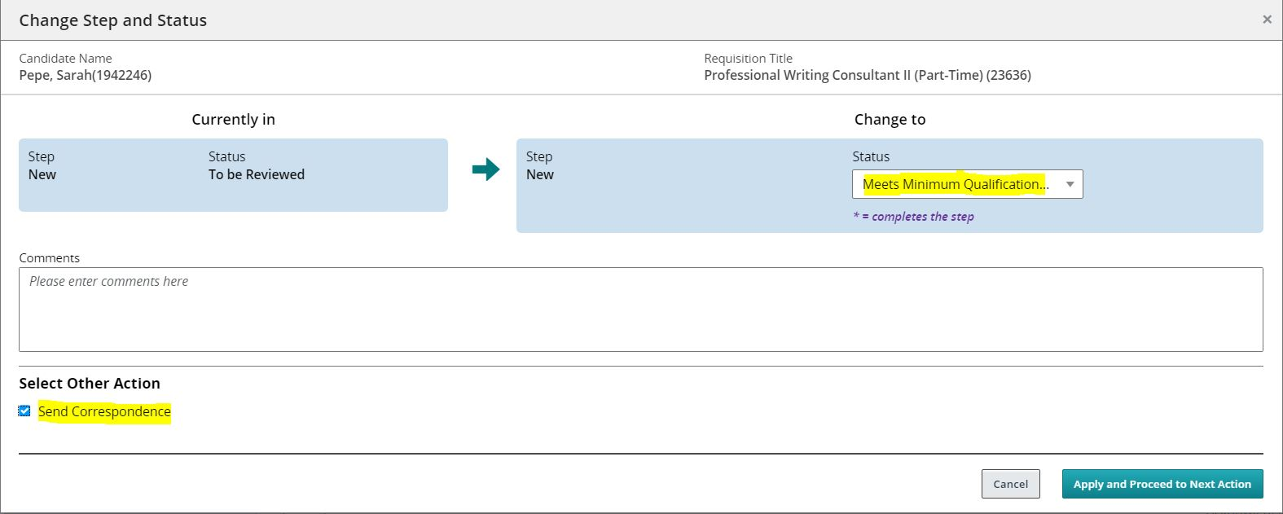

- The following window will populate. No changes need to be made to this section. Just click Next.

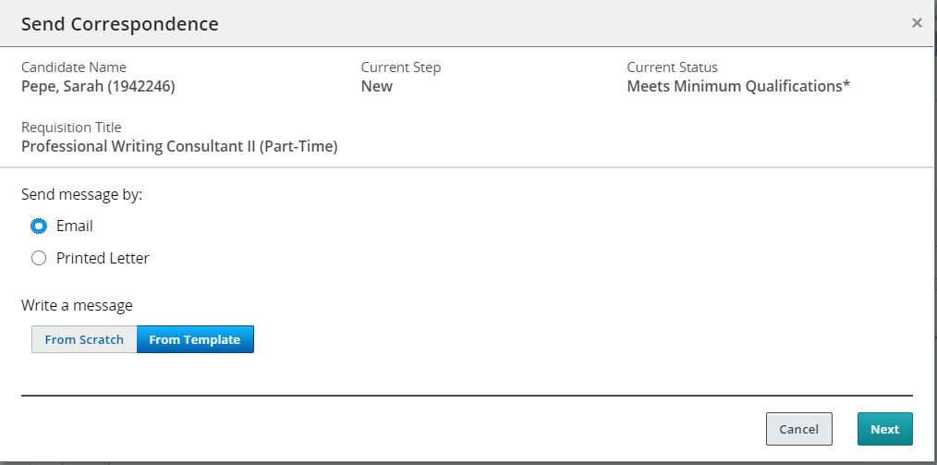

- Scroll through the options on the left-hand side of the screen and select the following template: “UCD Met Minimum Qualifications - University Staff”. Click the Select Template button.

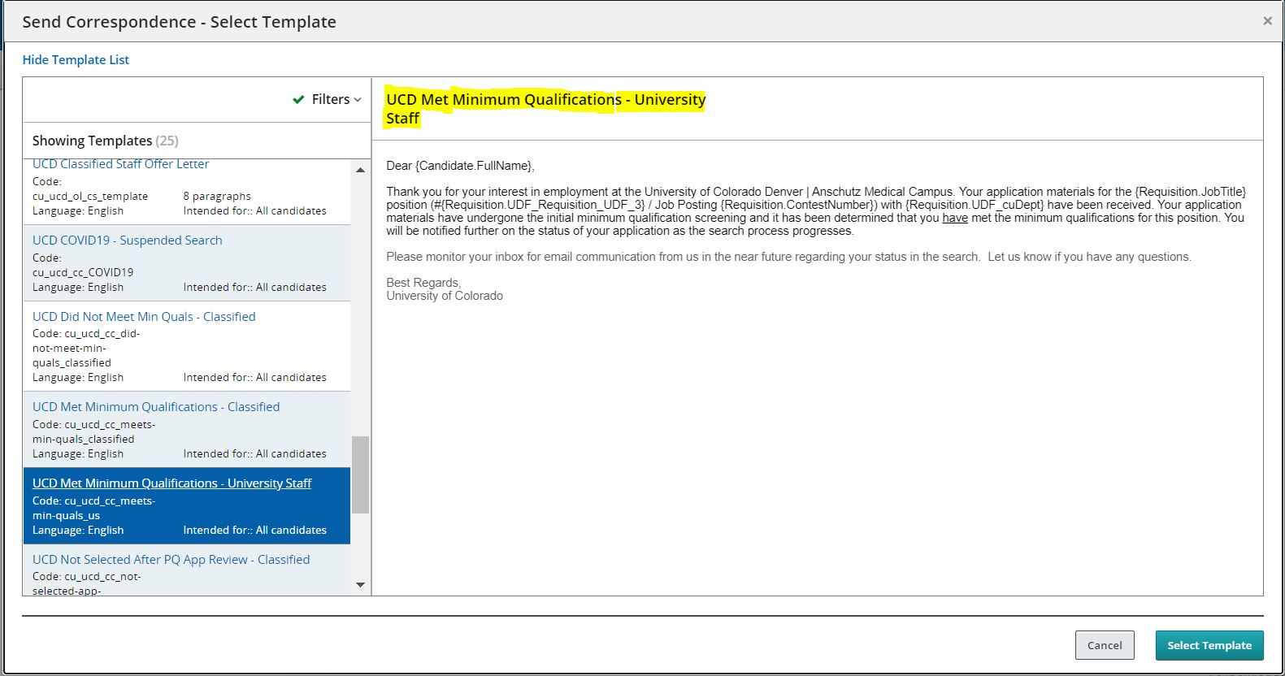

  - The system will populate an example of the notification for your review. If all elements look accurate, click the Send & Close button.

Best Practice Tip: Once first round interviews have concluded it is best practice that the HRBP notify these candidates of their Not Selected status. Please follow guidance outlined in Step 8, to finish the notification and dispositioning process.

- Disposition Dispositioning & Notifications: Candidates who met all MQs. NOTE: Candidates at this point in the recruitment process may be routed into three categories.

Candidates who meet all MQs and have been selected for interviews.

  - Select all applicable candidates by checking the box next to their name. Then click the More Actions drop down menu.

  - Within the drop-down menu select the “Change Step/Status” option.

  - Confirm that “Meets Minimum Qualifications” is in the status bar. Then click Apply and Continue.

  - Change the Status to “Selected for Interviews”. Then click Apply and Continue.

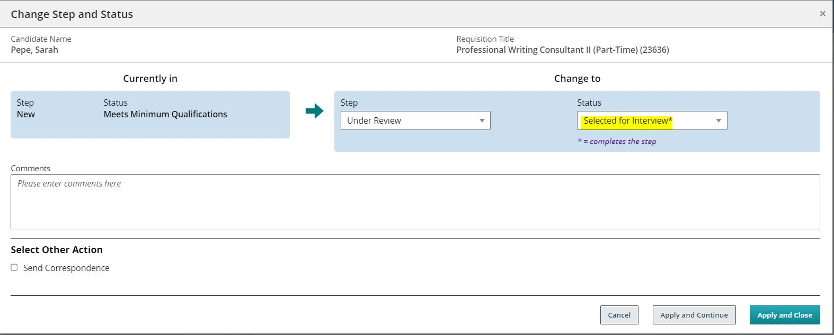

  - Change the Status to “Interview”. Then click Apply and Close.

Best Practice Tip: Since these candidates will receive an invitation to interview, they will not need to receive a notification from the system.

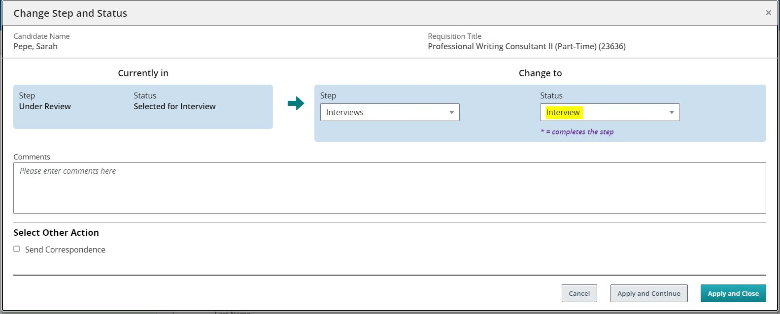

- Dispositioning & Notifications: Candidates who participated in 1st round interviews, but were not referred for 2nd round interviews.

  - Select all applicable candidates by checking the box next to their name. Then click the More Actions drop down menu.

  - Within the drop-down menu select the “Change Step/Status” option.

  - Change the Status to “Not Selected” and select the most appropriate Details of Disposition. Then click Apply and Close.

Best Practice Tip: Candidates who interview should not receive a template notification from CU Careers. Instead they should receive a personal notification from the Department either over the phone or via email. Please contact TAC with any questions.

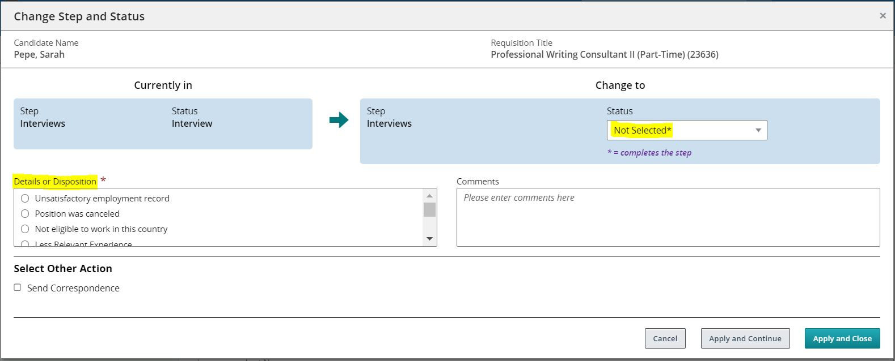

- Dispositioning & Notifications: Candidates who participated in 1st round interviews and were referred for 2nd interviews.

  - Select all applicable candidates by checking the box next to their name. Then click the More Actions drop down menu.

  - Within the drop-down menu select the “Change Step/Status” option.

  - Change the Status to “2nd Interview”. Then click Apply and Close.

Best Practice Tip: Since these candidates will receive an invitation to interview, they will not need to receive a notification from the system.

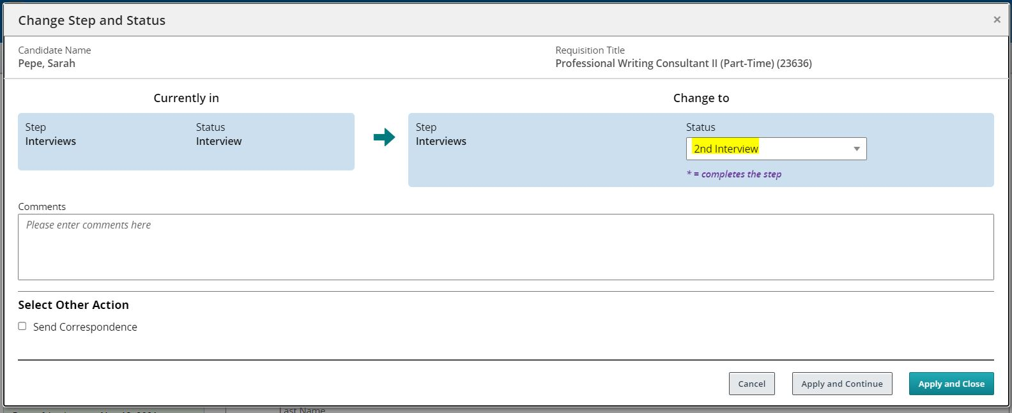

- Dispositioning & Notifications: Candidates who participated in 2st round interviews, but were not selected for the position.

  - Select all applicable candidates by checking the box next to their name. Then click the More Actions drop down menu.

  - Within the drop-down menu select the “Change Step/Status” option.

  - Change the Status to “Not Selected” and select the most appropriate Details of Disposition. Then click Apply and Close.

Best Practice Tip: Candidates who interview should not receive a template notification from CU Careers. Instead they should receive a personal notification from the Department over the phone or via email. Please contact TAC with any questions.

- Dispositioning & Notifications: Candidates who applied after the full-consideration deadline or late in the recruitment process.

  - Select all applicable candidates by checking the box next to their name. Then click the More Actions drop down menu.

  - Within the drop-down menu select the “Change Step/Status” option.

  - Change the Status to “Not Selected”, select the most appropriate Details of Disposition (i.e. Application received past priority deadline), and check the send correspondence box. Click on the Apply and Proceed to Next Action button.

  - The following window will populate. Since we do not have a saved template for this group, select the “Scratch” option and click Next.

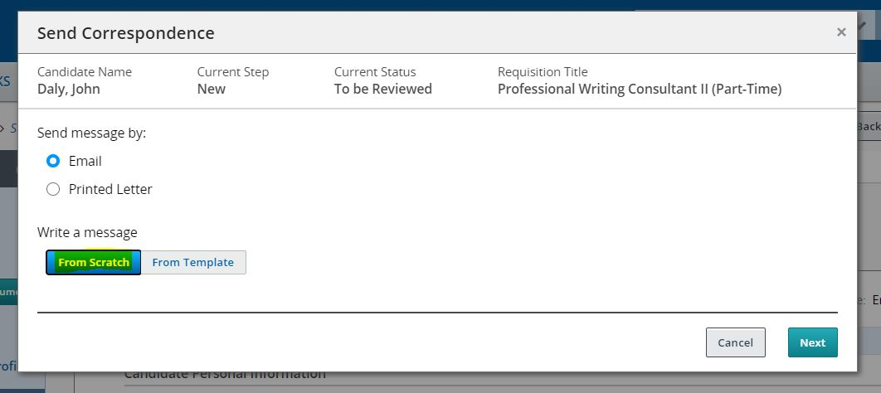

  - The following screen will populate. NOTE: Our office has created language for the subject line and body of the email. This information contains formatting and text specific to CU Careers.

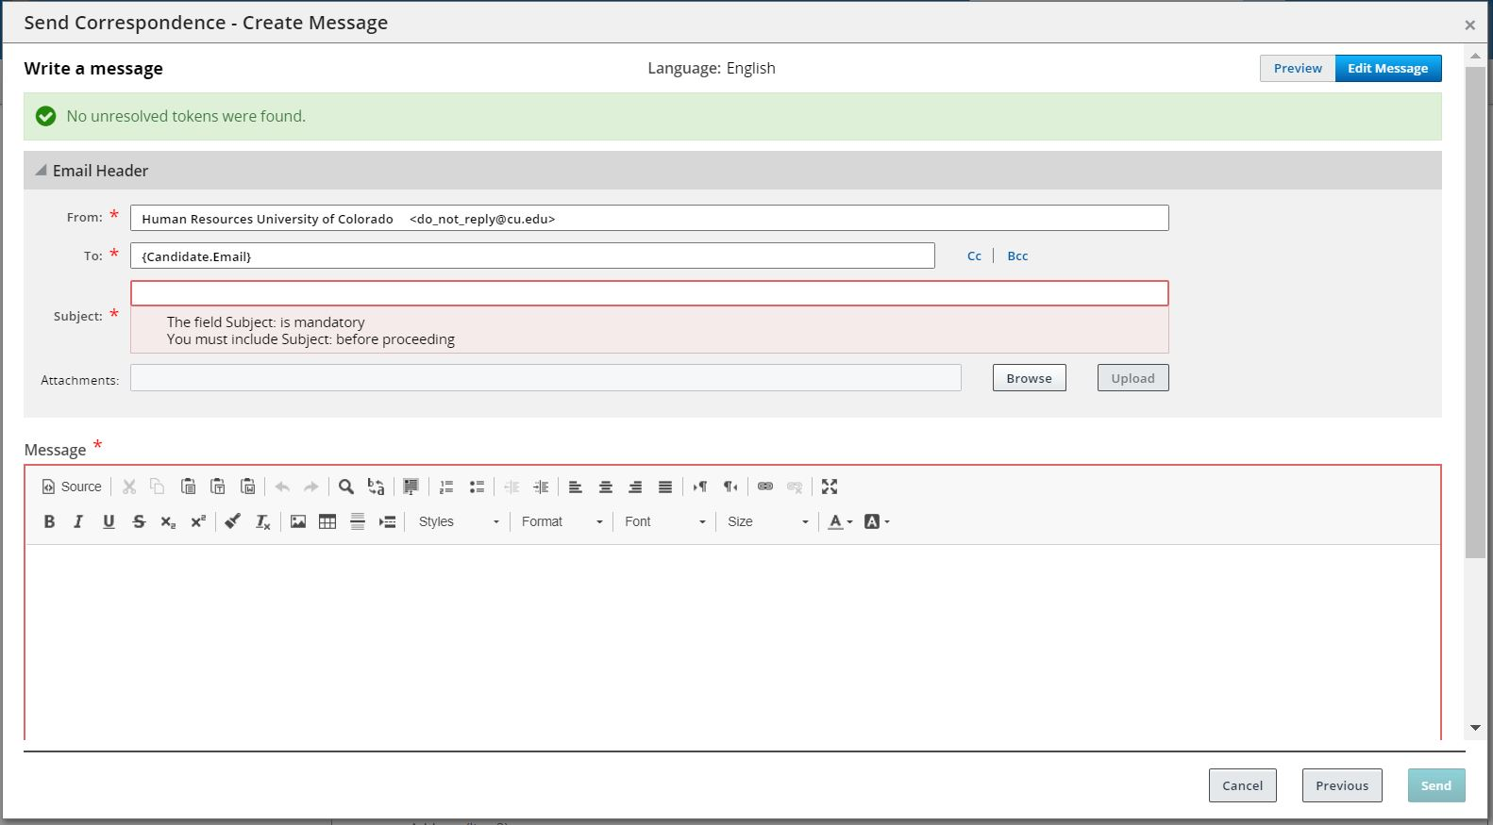

  - Subject Line: {Requisition.JobTitle} - Applied After Consideration Date or Interviews

  - Body of Email:

{Other.CompanyLogos1}

{Other.CurrentDate}

Dear {Candidate.FirstName},

Thank you for your interest in the {Requisition.JobTitle} position (Requisition #{Requisition.Number}) with the {Requisition.UDF_cuDept} at the University of Colorado.

Unfortunately, your application arrived after the search committee was already in the process of reviewing and interviewing applicants and we are moving forward with those other candidates.

We wish you success in your current job search and we encourage you to continue to apply for other positions that interest you. To view our current openings, please visit: www.cu.edu/cu-careers.

If you have any questions, please feel free to contact me directly.

Sincerely,

{Requisition.UDF_cuPostingContactName}
{Requisition.UDF_cuPostContactEmail}

Please do not reply to this email. Replies to this message are undeliverable.

Best Practice Tip: We are still experiencing formatting issues in CU Careers. It is recommended that you use an HTML Striper when drafting notifications in CU Careers. Link to HTML Striper - https://www.striphtml.com/.

  - Once you have completed all required sections, click Send.

