General Senate Meeting Agenda Monday, October 24, 2022
CU Anschutz – Education 2 – North 1107 5:00 pm – 7:00 pm
Scribe: Grace K. and Jeff O.

- Opening (5:00)
  - Call to Order
  - Welcome
  - Attendance
  - Approval of Minutes – Nick D.
    - Motion approved

- Announcements
  - Welcome from President – Sean H.

- Reports
  - President – Sean H.
    - Met with authors of Student Fee proposal
    - CU Anschutz gear, conference room, and coffee area on third floor of Ed 2
    - Constitution Committee started, goal of one month to ratify
    - Intercampus Student Forum (other Presidents of CU campuses)
      - All want to work on conceal carry ban
        - Possibility form Senate Committee on this, reach out to Sean
    - Has been connecting with student councils across programs: SOM, SOP, CHAPA, Nursing, Public Health, Grad school
      - Still waiting on Dental School
      - Trying to attend meeting for each
    - Next week another meeting with Chancellors
  - Vice-President – Nick D.
    - Goal: engage in communication with student population and senators so they know who Senate is and what we do
    - Draft census of students to see from campus, departments, etc.
    - Connect with each senator to see outlook to create overall plan (Google Poll) likely as 1:1 with as many senators as possible
  - Vice-President of Communicaton – Jeffrey O.
    - Roster: 41 people in Senate
      - Roster Gaps: Graduate school, Modern Human Anatomy
      - Per constitution room for up to 64
    - Meeting schedule:
      - Wants to determine how to set up meetings,
      - All of the programs calendars are in one place but there is no calendar with a campus-wide schedule
        - https://www.cuanschutz.edu/registrar/academic-calendars/2022-2023
  - Vice-President of Finance – Sierra L.
    - Approved 4 events: Interprofessional Addiction Medicine Student Interest Group (opiate addiction and naloxone meeting), Biomedical Engineering Society, Loops and Exchange, CU Orchestra
  - Woodgrain Prices Committee – Grace K.
    - Finished survey: https://ucdenver.co1.qualtrics.com/jfe/form/SV_aWBpWaz9IcmUxBs
    - Finished poster
    - Will send draft paragraph and official title to senate as a whole for them to disperse to students and to include in newsletter
    - Will also print off and put up around Ed1 and 2
    - Once formally approved, please send this to your program in whatever way you determine best (email, Facebook group, etc.)
  - Constitution Commitee – Dorah L.
    - No current updates, Dorah received materials today

- New Business
  - Call for Scribe:
    - Libby (CHAPA) will do minutes for the month of November
  - Nominations for Vice President of JEDI
    - Kevin Paik, MS1 (CUSOM)
  - Opportunity to Speak for Vice President of JEDI candidates
    - No new nominations
  - Vote for Vice-President of JEDI
    - Approved
  - Call for Finance Committee
    - Less than $500 can be approved through the finance committee
      - Bimonthly meetings to approve
      - Volunteers for Finance committee?
        - Gam (Dental), Marissa (Dental), Brenna (CHAPA)
      - Contact Sierra if you are interested in joining!
    - $500 to $1000 must have group come in person
  - Constitution Discussion
    - If any concerns about what gets added please contact Dorah
  - Senate Retreat
    - Three possible dates 11/13, 12/10, 12/11
    - ~80% prefer mornings
      - Will vote one final dates, probably between 12/10or11
    - Greta is appointed the Chair of the Retreat planning committee
      - Also on the committee
        - Ellie Carrington
        - Audrey Warner
  - Funding Request Vote – Katelyn M.
    - Limited budget where we need to determine what we can fund and where our priorities are
    - Expenses
      - Committed $7000 to Student Health Promotions Committee and CU Empower each
      - Expect $10-12k on student groups
      - Senate operating expenses are $10,000
    - Income
      - Student Fee
    - Funding Request needs to be reassessed due to cost
      - Concert series $5,000
      - Intramurals
      - Museum (explore Denver) - $6,000
      - Sports games, Winter Fest, First Bloom – larger priced single event items
    - Exec team will meet to discuss further, and the Senate will vote once a constitution is in place
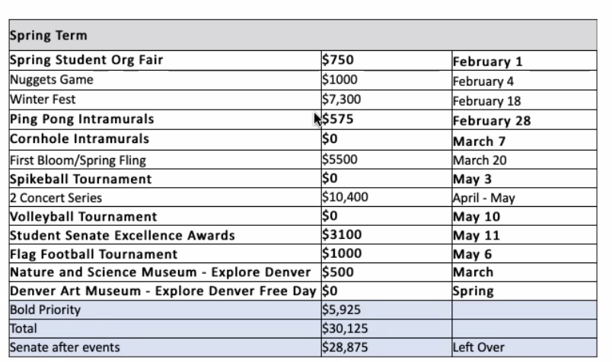
  - Open comments (Libby Greenwell)
    - Can we have any influence over the fact that people’s food is being thrown out from the refrigerators in Ed1&2?
    - Utensils?
    - Water filters?
    - Expo markers?
    - Is it worthwhile to submit funding requests for conferences for different programs?
    - Libby is going to draft an email for Sean to send to the utilities

- Closing
  - Final Remarks
    - Now full executive board
    - Constitution in progress
  - Inspiration

- Meeting Adjourned (6:14)

- Committee Meetings (6:14-7:00)

